BOOTSTRAP MANUAL

**TABLE OF CONTENTS**

1. What is Bootstrap?

2. Installing Bootstrap

3. Features of Bootstrap

4. CSS Components

5. Javascript Widgets

6. Initializing Environment Setup

7. Basic Typography

8. Text Alignment and Display

9. Float and Fixed-positioning

10. Colors and Backgrounds

11. Spacing

12. Sizing Border

13. Buttons and Button Groups

14. Navbar and Navs

15. List Groups

16. Form

17. Alerts and Progress bar

18. Tables and pagination

19. Cards

20. Grid System

**1. WHAT IS BOOTSTARP**

Bootstrap is an open source front-end/UI/CSS framework for fast web/user interface development.

It gives us tools to create websites and applications UI and can get all types of utility classes (margin, padding, typography etc) as well as component classes that are pre-made (alert, progress bar etc).

It also has built in javascript widgets and plugins.

It is also easy to use, mobile first, responsive grid layout.

**Advantages of Bootstrap**

* Browser compatibility
* Faster Development
* Good for devs that lack design/UI skills
* Easy to learn
* Responsive by nature

**2. INSTALLING BOOSTRAP**

They are three ways of installing bootstrap

***a. Include The CDN(content delievery network):*** This is very fast because file are serve from high capacity infrastructures, and does not bug up your server and it can boost performance and save money.

***b. Download and Include Files***: You can also download the file from getbootstrap.com but not okay for deployment, just for local production.

***c. Package Managers -NPM/Yarn:*** We can use package manager like the node package manager (NPM) or Yarn but is little more complicated, because you will be using the command line (cmd)

**3. FEATURES OF BOOTSTRAP**

1. **Grid System :** This uses flex box and completely responsive
2. **Text and Typography :** This classes are used for alignment and font sizing
3. **Positioning:** This is how we display elements as block or inline
4. **Spacing :** This class is for margin and padding on any side we want
5. **Sizing :** This is classes for widths and heights
6. **Alignment:** For text and any other elements
7. **Colors:** As the name implies, for background, text and buttons etc.
8. **Images:** This classes is for fitting in images in a container and making it have shapes.
9. **Responsive Utilities:** This if you want your web app to show on small screens or large screens.
10. **Shadows:** To add effects on the background or text

**4. CSS COMPONENTS**

1. **Forms and Input Groups:** Bootstrap gives us a nice form display unlike the ordinary html form.
2. **Tables:** They are special class to create nice table.
3. **List groups:** This display list items in nice way like nav menu, side menu etc.
4. **Cards:** This is also use to display contents in many different ways.
5. **Progress Bars:** This can be animated.
6. **Alerts:** for display success and error message.
7. **Navbar and Menus:** This is easier in bootstrap than pure html and css
8. **Buttons & Button Groups:** This is for displaying nice button with good interface.
9. **Pagination:** To select or slide through different pages.
10. **Media Objects:** This is mostly use for news site and blogs.
11. **Jumbotron:** Use for showcasing or displaying areas that call for focus.
12. **Badges:** This goes well with list groups

**5. JAVASCRIPT WIDGETS**

* **Carousel Slider:** This includes, indicators, arrows where we can set option.
* **Collapsible Accordion:** If we want to click on a button and make content slide down and back.
* **Modals:** This are pop ups that can fade in and can be used to pop up messages or forms.
* **Tooltips:** This helps in showing details of content when mouse over.
* **Popovers:** This is also similar to tooltips.
* **Scrollspy:** This allows you to scroll through content and have that piece of content highlight in the nav menu

NB: We will need Jquery to make all this work

**6. INITIALIZING ENVIRONMENT SETUP**

1. Using the Download Bootstrap method

<!DOCTYPE html>

<html *lang*="en">

<head>

  <meta *charset*="UTF-8">

  <meta *http-equiv*="X-UA-Compatible" *content*="IE=edge">

  <meta *name*="viewport" *content*="width=device-width, initial-scale=1.0">

*<!-- bootstrap css file -->*

  <link *href*="css/bootstrap.min.css" *rel*="stylesheet">

*<!-- main style -->*

  <link *href*="css/style.css" *rel*="stylesheet">

  <title>Welcome To Anchorsoft Academy</title>

</head>

<body>

<script *src*="js/jquery-3.5.1.js"></script>

<script *src*="css/bootstrap.min.js"></script>

</body>

</html>

When workings with this step always make sure your jquery script is above the bootstrap script. As well as the bootstrap css should be about our own inbuilt css. So that when we override a change it takes effect

2. Using the CDN

<!DOCTYPE html>

<html *lang*="en">

<head>

  <meta *charset*="UTF-8">

  <meta *http-equiv*="X-UA-Compatible" *content*="IE=edge">

  <meta *name*="viewport" *content*="width=device-width, initial-scale=1.0">

*<!-- bootstrap css file -->*

 <link *rel*="stylesheet" *href*="https://maxcdn.bootstrapcdn.com/bootstrap/3.3.7/css/bootstrap.min.css" *integrity*="sha384-BVYiiSIFeK1dGmJRAkycuHAHRg32OmUcww7on3RYdg4Va+PmSTsz/K68vbdEjh4u" *crossorigin*="anonymous">

*<!-- main style -->*

  <link *href*="css/style.css" *rel*="stylesheet">

  <title>Welcome To Anchorsoft Academy</title>

</head>

<body>

*<!-- Latest compiled and minified JavaScript -->*

<script *src*="https://maxcdn.bootstrapcdn.com/bootstrap/3.3.7/js/bootstrap.min.js" *integrity*="sha384-Tc5IQib027qvyjSMfHjOMaLkfuWVxZxUPnCJA7l2mCWNIpG9mGCD8wGNIcPD7Txa" *crossorigin*="anonymous"></script>

</body>

</html>

**7. BASIC TYPOGRAPHY**

Bootstrap 4 uses a default font-size of 16px, and its line-height is 1.5.

The default font-family is "Helvetica Neue", Helvetica, Arial, sans-serif.

In addition, all <p> elements have margin-top:0 and margin-bottom:1rem(16px by default.

**Headings**

  <h1>h1 Bootstrap heading (2.5rem = 40px)</h1>

  <h2>h2 Bootstrap heading (2rem = 32px)</h2>

  <h3>h3 Bootstrap heading (1.75rem = 28px)</h3>

  <h4>h4 Bootstrap heading (1.5rem = 24px)</h4>

  <h5>h5 Bootstrap heading (1.25rem = 20px)</h5>

  <h6>h6 Bootstrap heading (1rem = 16px)</h6>

*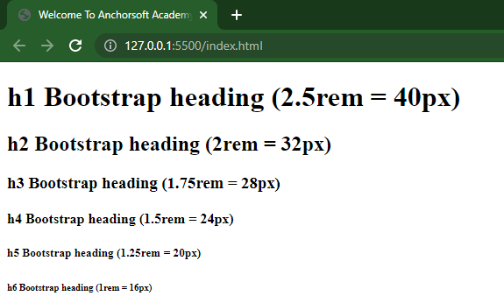Result In the browser*

We can keep the markup of an h4 but have the size of an h1, we can just add the class on the h4. And we can make it h2 or any kind we want

<h4 *class*="h1">h4 Bootstrap heading (1.5rem = 24px)</h4>

**Display Classes**

They make headings more prominent, which are cool for showcasing areas or hero block etc. we have from display-1 to display-4.

<h1 *class*="display-1">Display 1</h1>

<h1 *class*="display-2">Display 2</h1>

<h1 *class*="display-3">Display 3</h1>

<h1 *class*="display-4">Display 4</h1>

The code above are all having the same h1 but different display classes

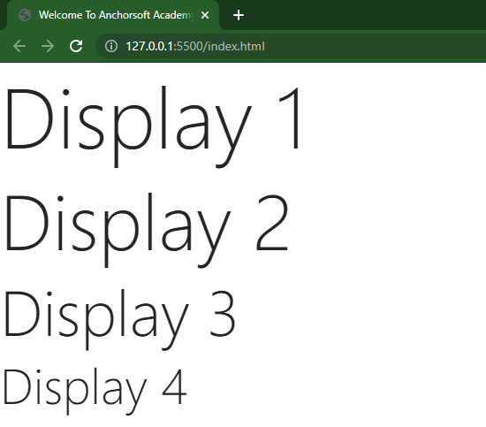*Result in the browser*

**Paragraphs**

This is just a normal paragraph; we can make it more prominent by adding some classes like the ***lead, monospace etc.***

***Lead class***

This just increase the font-size and font-weight of a paragraph

***Monospace class***

These just style the paragraph and make it have a mono look

<h5 >Paragraph</h5>

<p>Lorem, ipsum dolor sit amet consectetur adipisicing elit. Reprehenderit, consequuntur quis. Iste, in eaque cumque enim perspiciatis harum praesentium excepturi, expedita itaque laboriosam officia provident. Voluptates deleniti cum delectus amet.</p>

<h5>Paragraph With Lead Class</h5>

<p *class*="lead">Lorem, ipsum dolor sit amet consectetur adipisicing elit. Reprehenderit, consequuntur quis. Iste, in eaque cumque enim perspiciatis harum praesentium excepturi, expedita itaque laboriosam officia provident. Voluptates deleniti cum delectus amet.</p>

<h5>Paragraph With Monospace Class</h5>

<p *class*="text-monospace">Lorem, ipsum dolor sit.</p>

*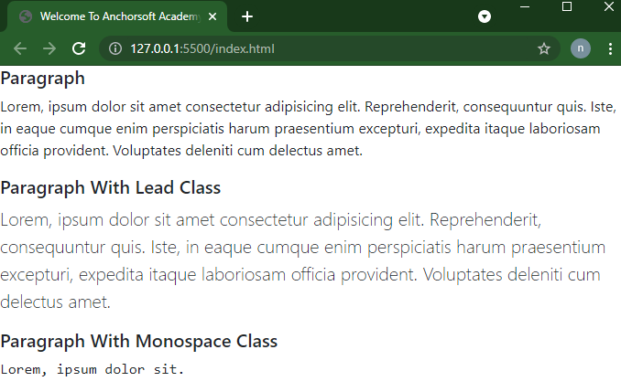Result in the Browser*

**Style Classes (Bold, Normal , Italic)**

*Bold:* These bold a text and not necessarily need to add the <strong> tag to it

*Normal:* This keeps the or other text wrapped in a strong tag.

*Italic:* These style the text and make it slant.

<p *class*="fw-bold">Bold Text</p>

<p *class*="fw-light">Normal Text</p>

<p *class*="fst-italic" >Italic Text</p>

*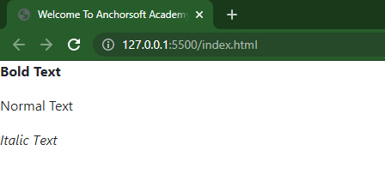Result in browser*

**Text Transformation (lowercase, Uppercase , Capitalized)**

*Lowercase:* It changes a text from upper or capitalize letter to lowercase

*Uppercase:* It changes a text from lower or capitalize letter to uppercase

*Capitalize:* It changes a text from upper or lower letter to capitalizing only the first letter of every word

<p *class*="text-lowercase">MAKE LOWERCASE</p>

<p *class*="text-uppercase">make uppercase</p>

<p *class*="text-capitalize">make capitalize</p>

*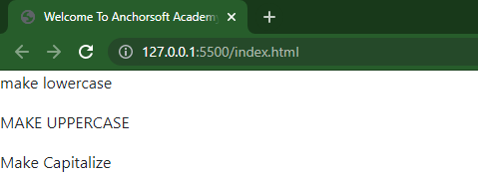Result in the browser*

**Blockquotes**

This just makes a text that is wrapped in it bigger and bolder.

<blockquote *class*="blockquote">

    <p>This is a blockquote</p>

</blockquote>

We can also align the blockquote to the right

<blockquote *class*="blockquote text-right">

    <p>This is a blockquoted aligned right </p>

</blockquote>

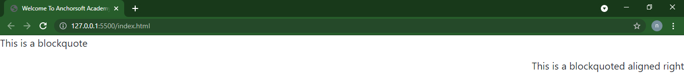*Result in the browser*

**Blockquotes with footer and cites**

<blockquote *class*="blockquote text-right">

    <p>Lorem ipsum dolor sit amet consectetur adipisicing elit. Quae, cupiditate.</p>

    <footer *class*="blockquote-footer">

      Anchorsoft Academy

      <cite *title*="Source Title">anchorsoftacademy.com</cite>

    </footer>

  </blockquote>

*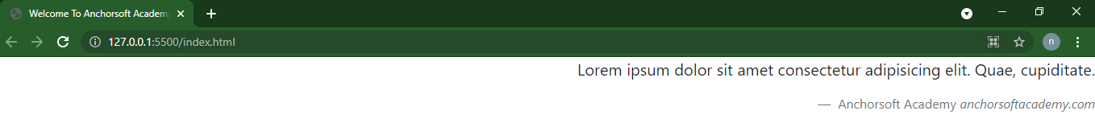Result in the browser*

**Text Truncate**

This truncate (shorten) large number of words and ends it with ..

<div *class*="text-truncate">

    Lorem, ipsum dolor sit amet consectetur adipisicing elit. Voluptatum adipisci odio necessitatibus quaerat culpa illum laboriosam eveniet maiores labore hic soluta quos, voluptatem nisi officiis fuga asperiores expedita! Itaque laudantium repellendus ad eius, aut deleniti est numquam vitae sunt provident voluptates! Repudiandae, veritatis id eaque iusto corporis quas eligendi illum.

    Lorem ipsum dolor sit amet, consectetur adipisicing elit. Error, temporibus?

</div>

*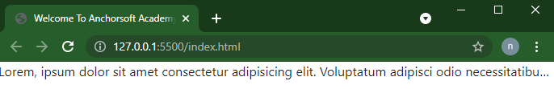Result in the browser*

**Lists**

Using the list-unstyled and list-inline; the list-unstyled class removes the bulletin on the list item, why the list-inline makes the list display horizontally, but the li must have list-inline-item

<ul *class*="list-unstyled">

    <li>Mango</li>

    <li>Apple</li>

    <li>Orange</li>

    <li>Banana</li>

 </ul>

  <ul *class*="list-inline">

    <li *class*="list-inline-item">Home</li>

    <li *class*="list-inline-item">About</li>

    <li *class*="list-inline-item">Contact</li>

    <li *class*="list-inline-item">Product</li>

  </ul>

*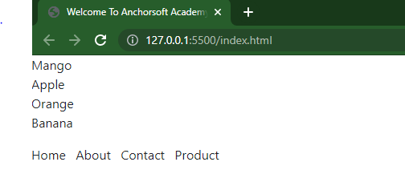Result in the browser*

**8. TEXT ALIGNMENT AND DISPLAY**

We have the Justify, left, center and right

<p *class*="text-justify"> Lorem ipsum, dolor sit amet consectetur adipisicing elit. Illo soluta beatae magnam tenetur delectus pariatur qui harum neque est minus odit voluptatibus maxime placeat sapiente ducimus animi odio vitae dolorum, labore sint! Fugiat ea aperiam beatae nobis cum maiores non.

</p>

<p *class*="text-start">Text left</p>

<p *class*="text-right">Text right</p>

<p *class*="text-center">Text center</p>

*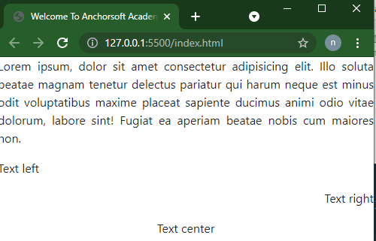Result in the browser*

**Turn Block to Inline**

This is using the d-inline class to make a block level element display like as inline

  <h3 *class*="d-inline bg-success">Anchorsoft</h3>

  <h3 *class*="d-inline bg-primary">Academy</h3>

**Turn Inline to Block**

This is using the d-block class to make a block level element display like as inline

<span *class*="d-block bg-warning">Anchorsoft</span>

<span *class*="d-block bg-dark">Academy</span>

*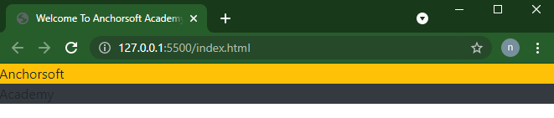Result in the browser*

**9. FLOAT AND FIXED-POSITIONING**

We also have the left, right and none float class

<div *class*="float-left bg-success">float left</div>

<div *class*="float-right bg-warning">float right</div>

<div *class*="float-none bg-primary">float none</div>

*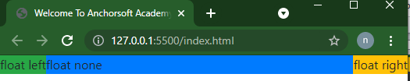Result in the browser*

**Clear fix**

This helps to position text, buttons etc well when floated without using the left and right. It also makes whatever comes next to go under it.

<div *class*="bg-info clearfix">

    <button *class*="float-left">float left</button>

    <button *class*="float-right">float right</button>

  </div>

*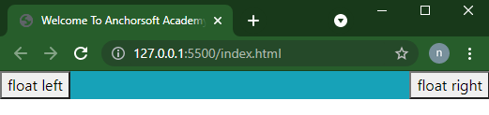Result in the browser*

**Fix top, Sticky and Fix bottom**

The Fix top sticks content at the top of the page even if the page is scroll it won’t move from the top.

The Stick makes content stay at the top when the page is scroll it won’t move from the top unless you scroll the other way round

The Fix bottom just like the fix top sticks content at the bottom of the page even if the page is scroll it won’t move from the top.

<h3 *class*="fixed-top"> Fix top</h3>

<h3 *class*="sticky"> Sticky</h3>

<h3 *class*="fixed-bottom"> Fix bottom </h3>

*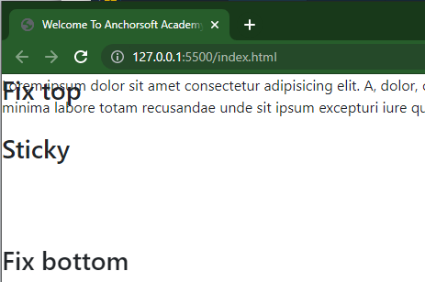Result in the browser*

**10. COLORS AND BACKGROUNDS**

**Text Colors**

<p *class*="text-primary">Text Primary color</p>

<p *class*="text-secondary">Text Secondary color</p>

<p *class*="text-success">Text Success color</p>

<p *class*="tect-info">Text Info color</p>

<p *class*="text-warning">Text Warning color</p>

<p *class*="text-danger">Text Danger color</p>

<p *class*="text-light">Text Light color</p>

<p *class*="text-dark">Text Dark color</p>

<p *class*="text-white">Text White Color</p>

<p *class*="text-mute">Text Muted</p>

<p *class*="text-black-50">Text Black 50</p>

<p *class*="text-white-50">Text White 50</p>

*Result in the browser*

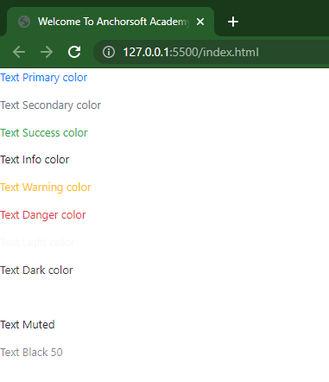

**Links Colors**

<p><a *href*="" *class*="text-primary"> Primary Link</a></p>

<p><a *href*="" *class*="text-secondary"> Secondary Link</a></p>

<p><a *href*="" *class*="text-info"> Info Link</a></p>

<p><a *href*="" *class*="text-success"> Success Link</a></p>

<p><a *href*="" *class*="text-warning"> Warning Link</a></p>

<p><a *href*="" *class*="text-danger"> Danger Link</a></p>

<p><a *href*="" *class*="text-light"> Light Link</a></p>

<p><a *href*="" *class*="text-dark"> Dark Link</a></p>

<p><a *href*="" *class*="text-muted"> Muted Link</a></p>

<p><a *href*="" *class*="text-white"> White Link</a></p>

*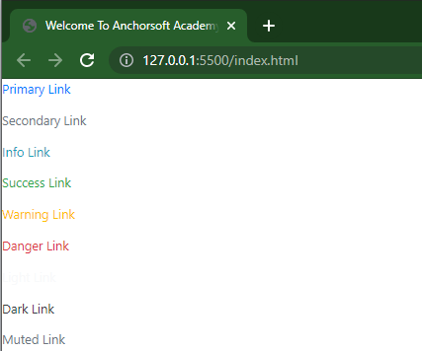Result in the browser*

**Backgrounds Colors**

<div *class*="bg-primary text-white">Background Primary Color</div>

<div *class*="bg-secondary text-white">Background Secondary Color</div>

<div *class*="bg-success text-white">Background Success Color</div>

<div *class*="bg-info text-white">Background Info Color</div>

<div *class*="bg-warning text-white">Background Warning Color</div>

<div *class*="bg-danger text-white">Background Danger Color</div>

<div *class*="bg-light text-dark">Background Light Color</div>

<div *class*="bg-dark text-white">Background Dark Color</div>

<div *class*="bg-white text-dark">Background White Color</div>

<div *class*="bg-transparent text-dark">Background Transparent Color</div>

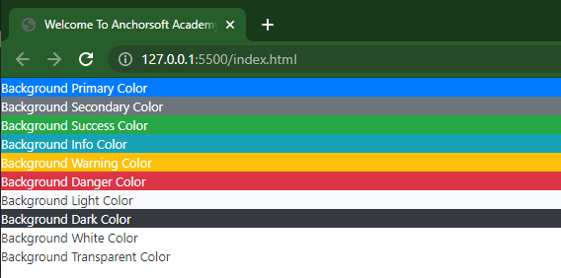*Result in the browser*

**11. SPACING**

**Margin**

This is the spacing outside the container, we have margin from 0 to 5 i.e m-0 to m5.

*Margin and Sides*

mt- margin top

mb- margin bottom

ml- margin left

mr- margin right

mx-auto: this take the away the left and right sides of the container automatically.

my-auto: this take the away the top and bottom sides of the container automatically.

<h3 *class*="m-0 bg-primary">Marign O</h3>

<h3 *class*="mt-1 bg-primary">Margin top</h3>

<h3 *class*="mb-2 bg-primary">Margin bottom</h3>

<h3 *class*="ml-3 bg-primary">Margin left</h3>

<h3 *class*="mr-4 bg-primary">Margin right</h3>

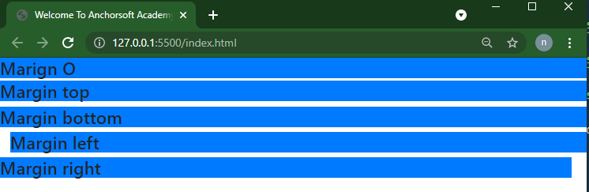*Result in the browser*

**Padding**

This is the spacing inside the container; we have padding from 0 to 5 i.e p-0 to p5.

*Padding and Sides*

pt- padding top

pb- padding bottom

pl- padding left

pr- padding right

px-auto: this take the away the left and right sides of the container inside automatically.

py-auto: this take the away the top and bottom sides of the container inside automatically.

<h3 *class*="p-0 bg-primary"> Padding O</h3>

<h3 *class*="pt-1 bg-primary"> Padding top</h3>

<h3 *class*="pb-2 bg-primary"> Padding bottom</h3>

<h3 *class*="pl-3 bg-primary"> Padding left</h3>

<h3 *class*="pr-4 bg-primary"> Padding right</h3>

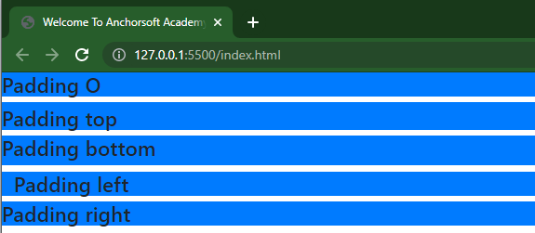*Result in the browser*

**12. SIZING BORDER**

**Width Class**

<div *class*="bg-success p-3 w-25">Width 25%</div>

<div *class*="bg-danger p-3 w-50">Width 50%</div>

<div *class*="bg-info p-3 w-75">Width 75%</div>

<div *class*="bg-success p-3 w-100">Width 100%</div>

<div *class*="bg-warning p-3 w-auto">Width auto</div>

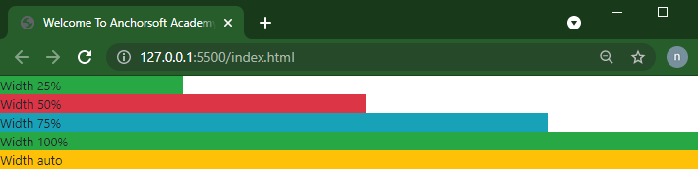*Result in the browser*

**Height Class**

<div *class*="bg-success d-inline-block  h-25">Height 25%</div>

  <div *class*="bg-danger d-inline-block  h-50">Height 50%</div>

  <div *class*="bg-info d-inline-block  h-75">Height 75%</div>

  <div *class*="bg-success d-inline-block  h-100">Height 100%</div>

  <div *class*="bg-warning d-inline-block  h-auto">Height auto</div>

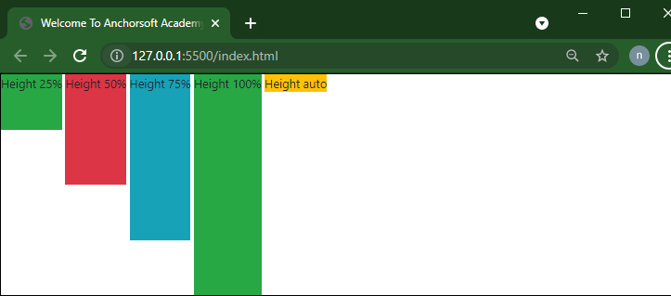*Result In the browser*

**Border with Border-colors Class**

  <div *class*="p3 mb-2 bg-info border border-primary">Regular with primary color </div>

  <div *class*="p3 mb-2 bg-info border-top border-secondary">Border top with secondary color </div>

  <div *class*="p3 mb-2 bg-info border-bottom border-danger">Border bottom with danger color </div>

  <div *class*="p3 mb-2 bg-info border-right border-info">Border right with info color </div>

  <div *class*="p3 mb-2 bg-info border-left border-dark">Border left with dark color </div>

  <div *class*="p3 mb-2 bg-info border border-warning">Regular with warming color </div>

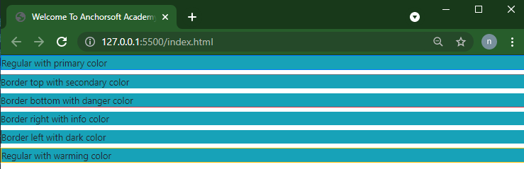*Result in the browser*

**Border Radius Class**

  <div *class*="p3 mb-2 bg-light border border-primary rounded">Regular Border Radius </div>

  <div *class*="p3 mb-2 bg-light border-top border-secondary rounded-right">Border Radius Right </div>

  <div *class*="p3 mb-2 bg-light border-bottom border-danger rounded-left">Border Radius Left </div>

  <div *class*="p3 mb-2 bg-light border-right border-info rounded-top">Border Radius Top </div>

  <div *class*="p3 mb-2 bg-light border-left border-dark rounded-bottom">Border Radius Bottom </div>

  <div *class*="p3 mb-2 bg-light border border-warning rounded-circle">Border Radius Circle </div>

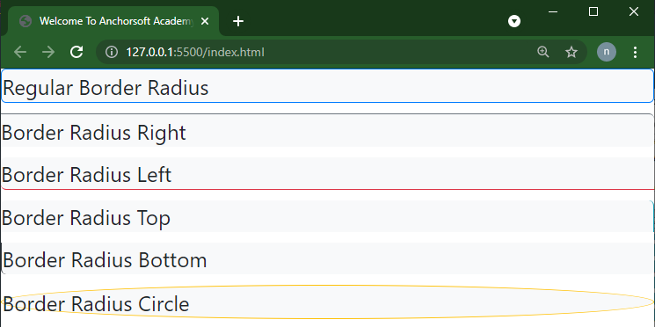*Result in the browser*

**13. BUTTONS AND BUTTON GROUPS**

The button in bootstrap takes multiple of class sytanx

.btn: the botton it self

.btn-primary: the color, primary, secondary, dark, light, warning etc

.btn-md: the size sm, md, lg etc

.btn-block: to occupy the width of it container

<button *class*="btn btn-primary">Primary</button>

<button *class*="btn btn-warning btn-sm">Small Warning</button>

<button *class*="btn btn-success btn-lg btn-block">Block Success</button>

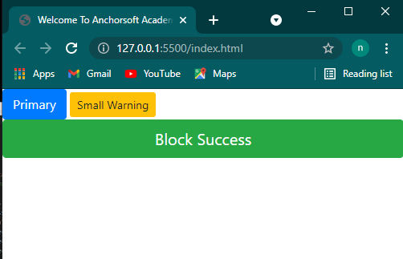*Result in the browser*

**Button Types**

<a *class*="btn btn-primary" *href*="" *role*="button"> Link botton</a>

<button *type*="submit" *class*="btn btn-success">Submit button</button>

<input *type*="button" *class*="btn btn-damger" *value*="Input button">

<input *type*="submit" *value*="input submit button" *class*="btn btn-warning">

<input *type*="reset" *value*="input reset button" *class*="btn btn-dark">

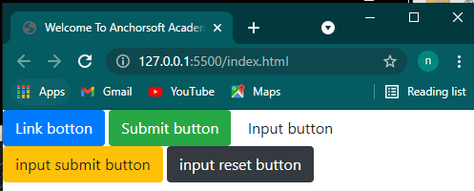*Result in the browser*

**Button Outline**

The outline has an hover effect that what makes it different from other button

<button *class*="btn btn-outline-primary">primary outline</button>

<button *class*="btn btn-outline-secondary">secondary utline</button>

<button *class*="btn btn-outline-warning">warning outline</button>

<button *class*="btn btn-outline-danger">danger outline</button>

<button *class*="btn btn-outline-dark">dark outline</button>

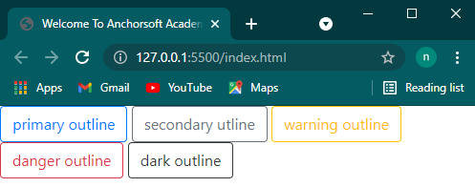*Result in the browser*

**Button Groups**

<div *class*="btn-group">

  <button *class*="btn btn-secondary">Left</button>

  <button *class*="btn btn-info">Middle</button>

  <button *class*="btn btn-danger">Right</button>

</div>

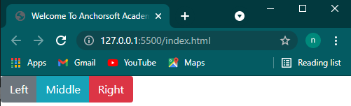*Result in the browser*

**14. NAVBAR AND NAVS**

**Simple Navbar**

<nav *class*="navbar navbar-expand-sm navbar-light bg-light">

  <div *class*="container">

    <a *href*="" *class*="navbar-brand">Anchorsoft Academy</a>

    <ul *class*="navbar-nav">

      <li *class*="nav-item">

         <a *href*="" *class*="nav-link"> Home </a>

      </li>

      <li *class*="nav-item">

         <a *href*="" *class*="nav-link"> About </a>

      </li>

      <li *class*="nav-item">

         <a *href*="" *class*="nav-link"> Our Courses </a>

      </li>

    </ul>

  </div>

</nav>

*Result in the browser*

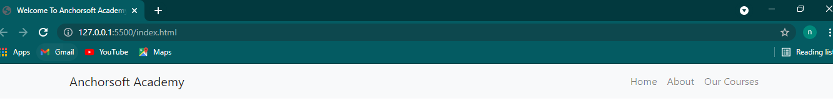.navbar: it the navbar itself

.navbar-expand-sm: this is the screen size you want it to respond to. i.e when it get to a small screen shrink the links

.container: we have explained this in the beginning, this just makes the content be aligned and have margin left and right

.navbar-brand: For logos

.navbar-nav: this is a nav container in a navbar for list items

.nav-item: as the name implies it takes in items whose parent has a class of nav

.nav-link: this is a link tag in a navbar-nav class of an ul

**Navbar with Toggle button**

<nav *class*="navbar navbar-expand-sm navbar-light bg-light">

  <div *class*="container">

    <a *href*="" *class*="navbar-brand">Anchorsoft Academy</a>

    <button *class*="navbar-toggler" *data-toggle*="collapse" *data-target*="#navid">

      <span *class*="navbar-toggle-icon"></span>

    </button>

   <div *class*="collapse navbar-collapse " *id*="navid">

      <ul *class*="navbar-nav">

        <li *class*="nav-item">

          <a *href*="" *class*="nav-link"> Home </a>

        </li>

        <li *class*="nav-item">

          <a *href*="" *class*="nav-link"> About </a>

        </li>

        <li *class*="nav-item">

          <a *href*="" *class*="nav-link"> Our Courses </a>

        </li>

      </ul>

   </div>

  </div>

</nav>

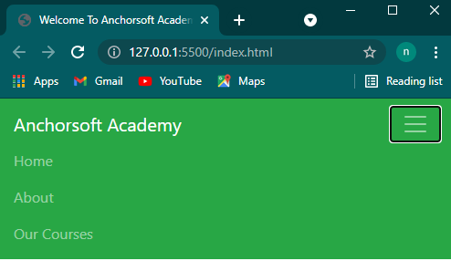*Result in the browser*

Making the nav to be responsive and show our links on a small screen, we add the button and span class

.navbar-toggler: this is the function of the botto

.data-toggle: this will locate a container that has a class of collapse

.data-target: this will point to the container id that houses the items

.navbar-toggler-icon: this appears on mobile screen as toggle icon that can be clicked as drop down

,navbar-collapse: this collapse the items in it

**Navbar with Forms**

*<!-- at the end of the ul tag  -->*

  <form *action*="" *class*="form-inline">

    <input *type*="text" *placeholder*="search" *class*="form-control mr-2">

    <button *class*="btn btn-outline-primary">Search</button>

   </form>

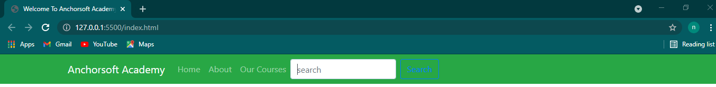*Result in the browser*

**15. LIST GROUPS**

<ul *class*="list-group">

      <li *class*="list-group-item">List one</li>

      <li *class*="list-group-item">List two</li>

      <li *class*="list-group-item">List three</li>

      <li *class*="list-group-item">List four</li>

 </ul>

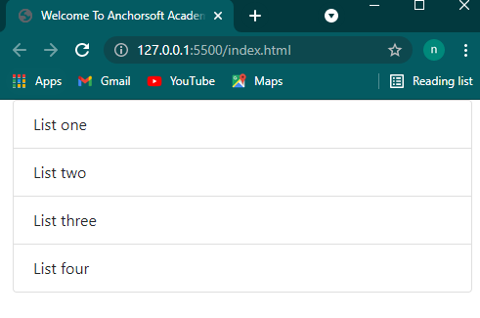*Result in the browser*

**List with colors**

<ul *class*="list-group">

      <li *class*="list-group-item list-group-item-primary">primary color list</li>

      <li *class*="list-group-item list-group-item-success">success color list</li>

      <li *class*="list-group-item list-group-item-info">info color list</li>

      <li *class*="list-group-item list-group-item-warning">warnin four</li>

      <li *class*="list-group-item list-group-item-danger">danger color list</li>

      <li *class*="list-group-item list-group-item-dark">dark color list</li>

    </ul>

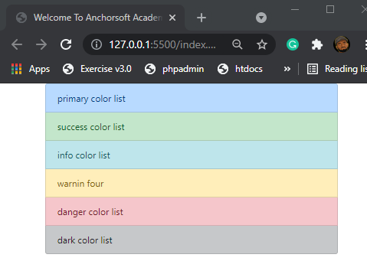*Result in the browser*

**16. FORM**

 <form *action*="">

    <h4>Text Field</h4>

     <div *class*="form-group">

      <label *for*="name">Name</label>

      <input *type*="text" *class*="form-control" *placeholder*="Enter name">

    </div>

    <div *class*="form-group">

      <label *for*="email">Email</label>

      <input *type*="email" *class*="form-control" *placeholder*="Enter email">

    </div>

    <div *class*="form-group">

      <label *for*="password">Password</label>

      <input *type*="password" *class*="form-control" *placeholder*="Enter password">

    </div>

    <h4>Select Field</h4>

    <div *class*="form-group">

     <label *for*="gender">Gender</label>

     <select *id*="gender" *class*="form-control">

      <option *value*="">Male</option>

      <option *value*="">Female</option>

     </select>

    </div>

   <h4>Text Area</h4>

   <div *class*="form-group">

    <label *for*="message">Message</label>

    <textarea *name*="" *rows*="3"></textarea>

   </div>

   <div *class*="form-group">

   <h4>File Input</h4>

    <label *for*="file">File</label>

    <input *type*="file" *id*="" *class*="form-control-file">

    <small *class*="form-text text-muted">Max 3mb size</small>

   </div>

   <div *class*="custom-file">

   <h4>Custom File Input</h4>

    <input *type*="file" *name*="file" *class*="custom-file-input">

    <label *class*="custom-file-label" *for*="file">Choose File</label>

  </div>

   <button *type*="submit" *class*="btn btn-primary btn-block">Submit</button>

</form>

*Result in the browser*

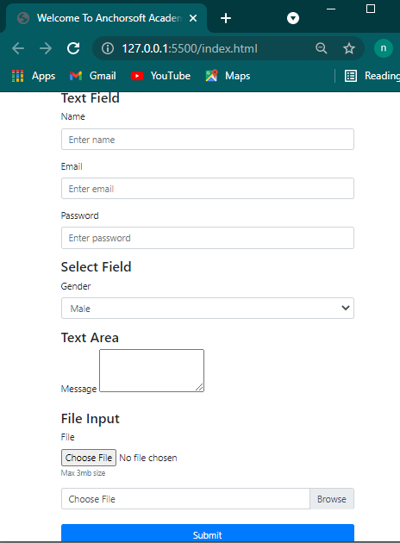

**Form Validation**

This form validation is used with JavaScript, all you need to add in the bootstrap form class is the “is-valid” for valid form and “is-invalid” for invalid form.

<form *action*="">

  <h4>Form Validation</h4>

   <div *class*="form-group">

     <label *for*="name">Username</label>

     <input *type*="text" *class*="form-control is-valid">

   <div>

     username correct

   </div>

 </div>

<div *class*="form-group">

  <label>Password</label>

  <input *type*="password" *class*="form-control is-invalid">

  <div>

   password not strong enough

  </div>

</div>

<div *class*="form-group">

  <label>Confirm password</label>

  <input *type*="password" *class*="form-control is-invalid">

   <div>

    password not match

   </div>

</div>

</form>

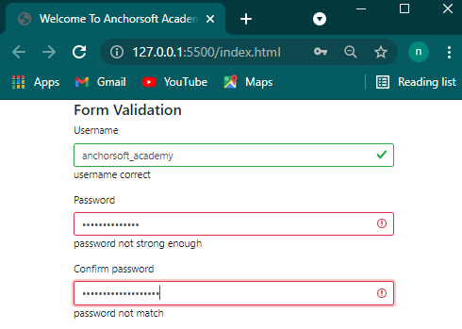*Result in the browser*

**17. ALERTS AND PROGRESS BAR**

**Alerts**

We have different kind of alerts, success, danger, primary, warning,dark,light, disabled alerts.

<h4>Normal Alert</h4>

   <div *class*="alert alert-primary">

     <strong>Primary</strong> form submited successfully!

   </div>

<h4>Dismissable Alert</h4>

   <div *class*="alert alert-danger alert-dismissible">

     <button *class*="close" *type*="button" *data-dismiss*="alert">

      <span>&times;</span>

     </button>

    <strong>Dissmissable</strong> Incorrect username/password

</div>

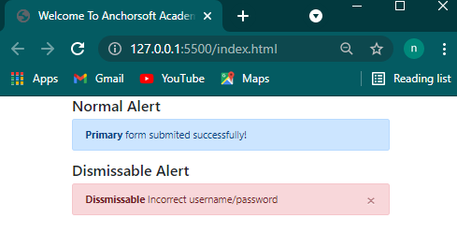*Result in the browser*

**Progress Bar**

<h4>Normal progress bar</h4>

        <div *class*="progress">

          <div *class*="progress-bar" *style*="width: 35%;"></div>

        </div>

        <h4>Progress bar with text</h4>

        <div *class*="progress">

          <div *class*="progress-bar" *style*="width: 50%;"> 50% loading</div>

        </div>

 <h4>Progress bar color</h4>

        <div *class*="progress">

          <div *class*="progress-bar bg-success" *style*="width: 55%;"> 55% loading color</div>

        </div>

<h4>Progress bar with striped</h4>

        <div *class*="progress">

          <div *class*="progress-bar bg-danger progress-bar-striped" *style*="width:30%;"> 30% loading striped</div>

        </div>

 <h4>Progress bar with animation</h4>

        <div *class*="progress">

          <div *class*="progress-bar bg-warning progress-bar-striped progress-bar-animated" *style*="width:70%;"> 70% loading animation</div>

        </div>

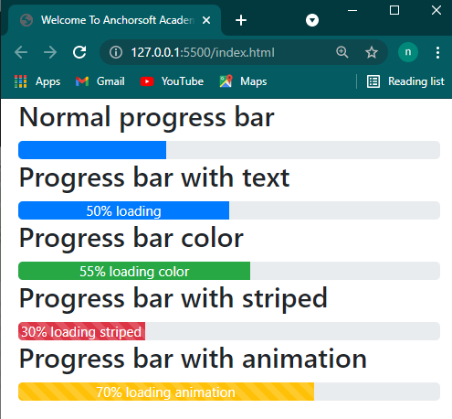*Result in the browser*

**18. TABLES AND PAGINATION**

**Table**

We have various table class, table, table-striped, table-bordered, table-borderless, table-sm, table-hover

<table *class*="table">

          <thead>

            <tr>

              <th>#</th>

              <th>First Name</th>

              <th>Last Name</th>

              <th>Email</th>

            </tr>

          </thead>

          <tbody>

            <tr>

              <th *scope*="row">1</th>

              <td>Anchorsoft</td>

              <td>Academy</td>

              <td>anchorsoftacademy@gmail.com</td>

            </tr>

            <tr>

              <th *scope*="row">2</th>

              <td>John</td>

              <td>Doe</td>

              <td>johndoe@gmail.com</td>

            </tr>

          </tbody>

        </table>

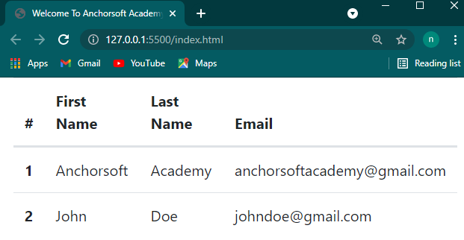*Result in the browser*

**Pagination**

This is the combination of nav and some list items

<nav>

          <ul *class*="pagination">

            <li *class*="page-item ">

              <a *href*="" *class*="page-link">Prev</a>

            </li>

            <li *class*="page-item active">

              <a *href*="" *class*="page-link">1</a>

            </li>

            <li *class*="page-item ">

              <a *href*="" *class*="page-link">2</a>

            </li>

            <li *class*="page-item ">

              <a *href*="" *class*="page-link">3</a>

            </li>

            <li *class*="page-item disabled">

              <a *href*="" *class*="page-link">Next</a>

            </li>

          </ul>

        </nav>

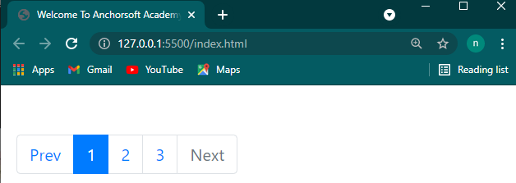*Result in the browser*

**19. CARDS**

This is a new concept that replace well and panels in older version of bootstrap, it comprises the card, card-header, card-body, card-title, card-footer, card-img-top, card-text, card-subtile etc classes

<div *class*="card">

    <img *src*="img/logo.jpg" *alt*="" *class*="card-img-top">

      <div *class*="card-header">

        <h4 *class*="card-title">Welcome to Anchorsoft</h4>

      </div>

      <div *class*="card-body">

        <h6 *class*="card-subtitle text-muted">Best programming academy</h6>

        <p *class*="card-text">Lorem ipsum dolor sit amet consectetur adipisicing elit. Esse, quos.</p>

     </div>

     <div *class*="card-footer">

      <a *href*="" *class*="btn btn-primary">Read More</a>

     </div>

    </div>

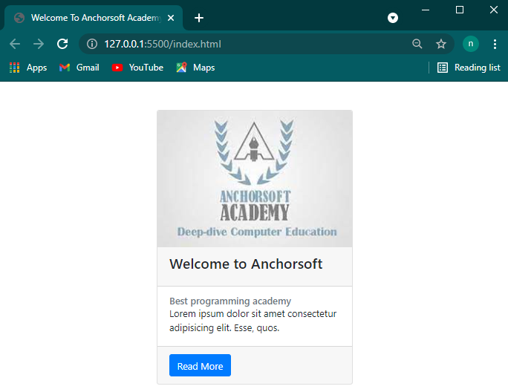*Result in the browser*

**20. JUMBOTRON**

This is a showcase area where you have a large heading and some text underneath.

Just give a div a class of jumbotron and it will display in a light-grey background

 <div *class*="jumbotron text-center">

      <h1 *class*="display-4"> Welcome To Anchorsoft Academy</h1>

      <p *class*="lead">Lorem ipsum dolor sit amet consectetur adipisicing elit. Nostrum, reiciendis porro. In, quam! Sit illo architecto, reprehenderit quas accusamus nobis!</p>

      <p *class*="lead">

        Lorem ipsum, dolor sit amet consectetur adipisicing elit. Veritatis, eius?

      </p>

      <a *href*="" *class*="btn btn-success btn-lg">Read More</a>

    </div>

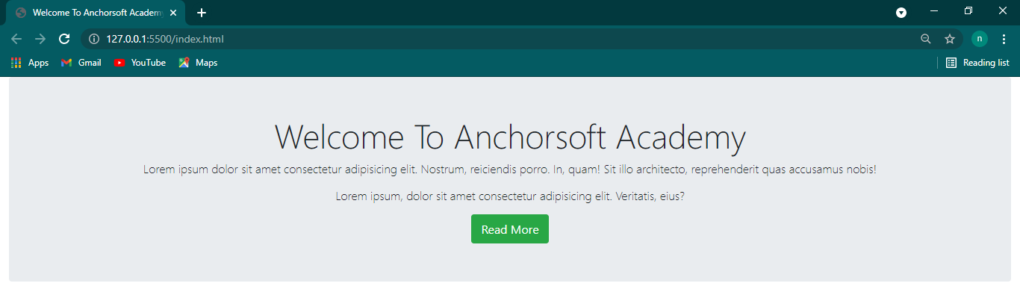*Result in the browser*

**21. GRID SYSTEM**

The grid divides a web page into 12 columns. Below are classes for each screen:

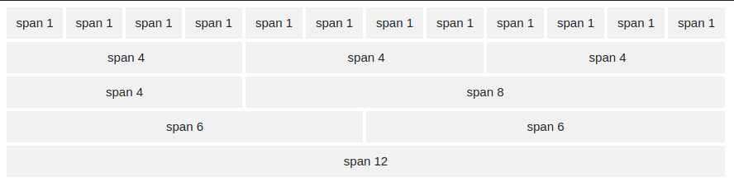

**Grid system sizes on devices**

.col-xs (extra small devices - screen width less than 576px)

.col-sm- (small devices - screen width equal to or greater than 576px)

.col-md- (medium devices - screen width equal to or greater than 768px)

.col-lg- (large devices - screen width equal to or greater than 992px)

.col-xl- (xlarge devices - screen width equal to or greater than 1200px)

**Basic Syntax**

The basic syntax is the .container, .row and .col

<div *class*="container">

    <h4>Two column grid system on medium screen</h4>

   <div *class*="row text-white">

*<!-- first is col-md-6 -->*

     <div *class*="col-md-6 bg-primary">Lorem ipsum dolor sit amet, consectetur adipisicing elit. Dignissimos numquam quibusdam assumenda unde, enim quam perferendis voluptatum sint quod, velit, omnis libero aspernatur dolorem saepe repudiandae hic nisi voluptas dolore!

    </div>

*<!-- second is col-md-6 -->*

    <div *class*="col-md-6 bg-success">Lorem ipsum dolor sit amet, consectetur adipisicing elit. Dignissimos numquam quibusdam assumenda unde, enim quam perferendis voluptatum sint quod, velit, omnis libero aspernatur dolorem saepe repudiandae hic nisi voluptas dolore!

    </div>

   </div>

  </div>

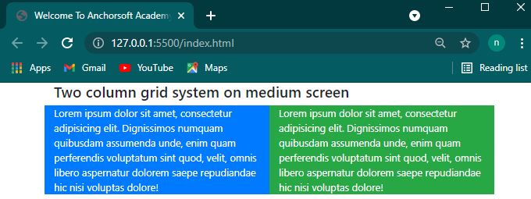*Result in the browser*

**Assignment**

Build a web page with **home, about, contact**, with just bootstrap and html, no css should be added